Adobe SSO Sign On Instructions
1. Some pre-requistes to do before attempting to sign in with SSO would be to open up any Adobe Application.
2. Navigate to the top right corner of your Adobe application (in this example we have Adobe Acrobat open). Click on the circle in the top right corner and it should bring you to a sub menu that looks like this.
3. In the sub menu click on Sign Out.
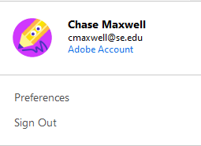
4. Once you click Sign out you will be met with this prompt. Click on Sign out again and it will sign you out and close your current Adobe application.
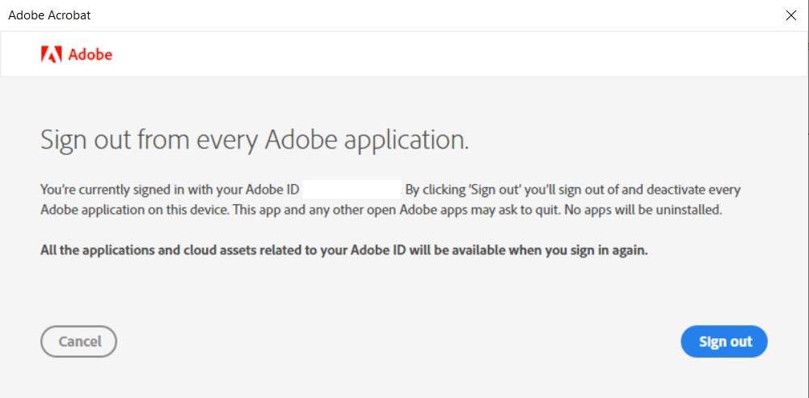

5. Now open up your Adobe application and you will be seeing a screen that looks like this. Enter your University Email in the line that says Email Address and click continue.
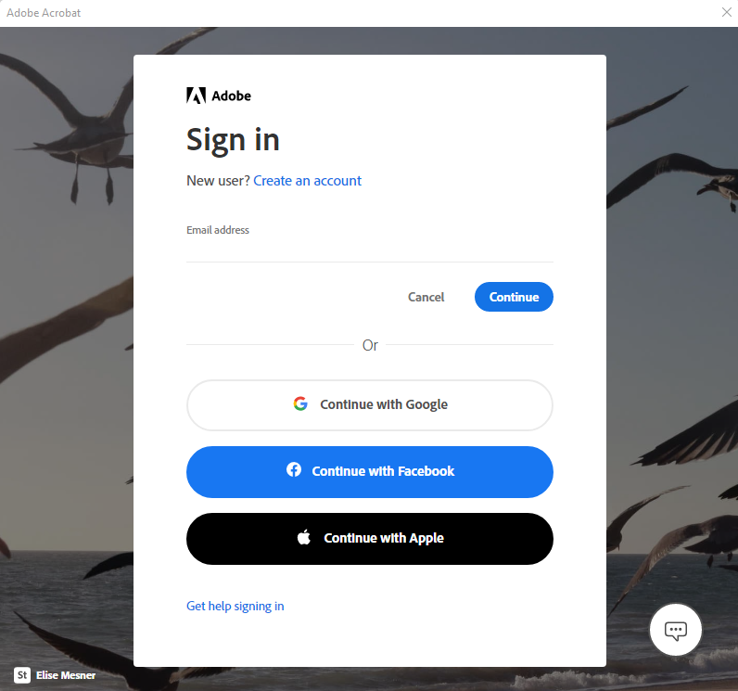
6. It will ask you to select an account like the provided picture below. Click on the arrow that says company or school account.
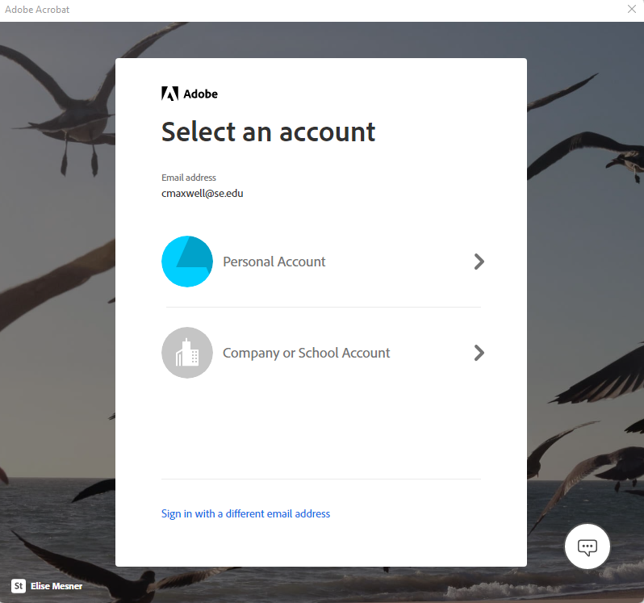
7. Once you click on the arrow it will take you to our Southeastern SSO page with the Library on the front of it in which you will put in your Southeastern credentials.
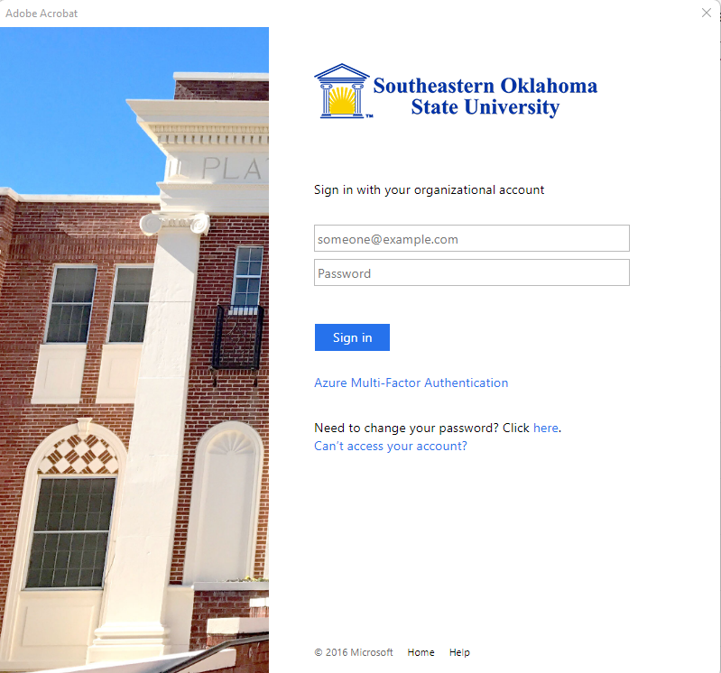
8. Once you put in your credentials you are now signed into Adobe and are ready to start using the Adobe products.

